# Setting up Application Environment Create Sendgrid Account

**Step 1.** Navigate to https://sendgrid.com

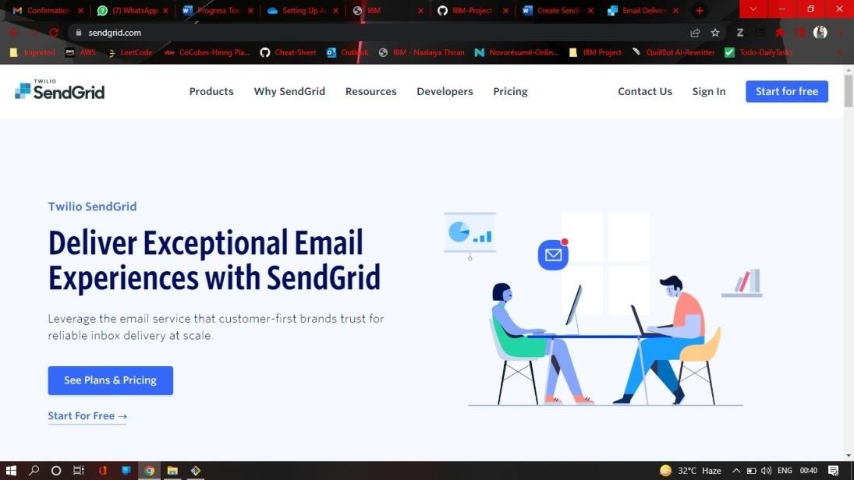**Step 2.** Click on “Start for free” and register yourselves by entering required details and click on create account

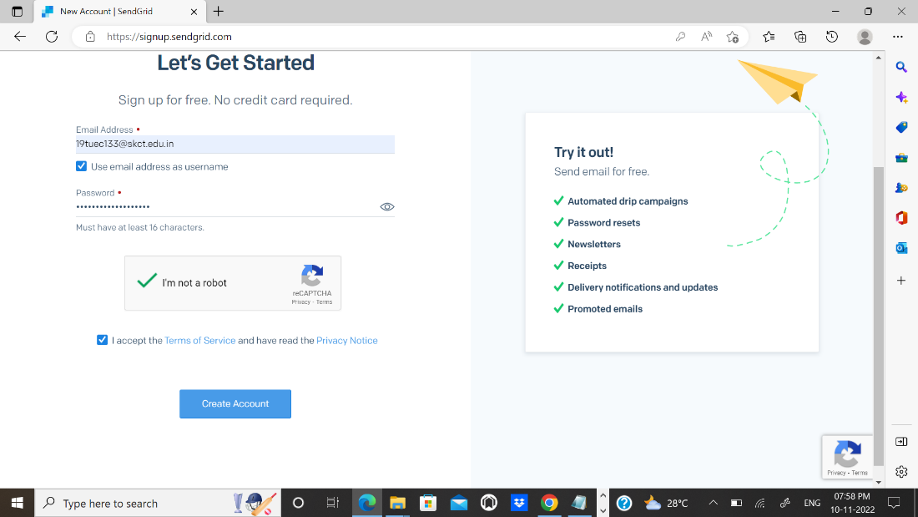**Step 3.** Further fill all required details in next page and click on get started as shown below

**Step 4.** That’s it you have created your SendGrid account and got access to dashboard

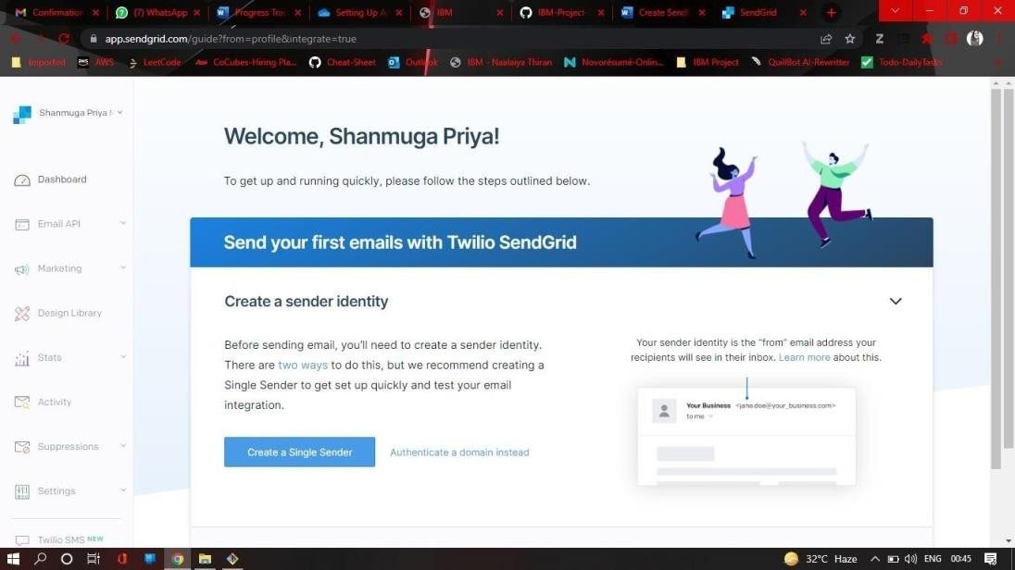

# Output:

Send Grid account created successfully.

\